Wei Xian Lim

Brian Dewall

English 150

3/29/2019

Campus Space and Art

Every sculpture has its own meaning. On the Iowa State University campus, there are many sculptures which always have a meaning that emphasize the purpose of education. Out of so many sculptures, the one which caught my eye is the sculpture about a man carrying a woman on his shoulder, seeming to cross the border. When you look closer, you can see a woman carrying an infant in her arms, trying to shelter her child from the outside element. This sculpture was created by an artist as he was concern about how discrimination affects people’s life which he uses his family member’s as an example.

The name of the artwork is called “Border Crossing”, it is a work of Luis Jimenez in 1987 (The Museum of Fine Arts, Border Crossing, 2018). Jimenez was an American sculptor of Mexican descent who was born in 1940 and passed away in 2006 (ISU, Border Crossing Sculpture). The artist was most widely known for his large-scale fiberglass sculptures (ISU, Border Crossing Sculpture). Same goes to the border crossing, he uses fiberglass as the medium of this artwork which gave this sculpture a bright, shiny and smooth surface. This is spray-painted with bright paint colors. The most prominent color is the burgundy red on the woman and the blue of the man’s jeans. It is said, “bright colors represent the colorful and energetic image of the Chicanos” (The Museum of Fine Arts, Border Crossing, 2018). Jimenez had shown his concern for working-class people and

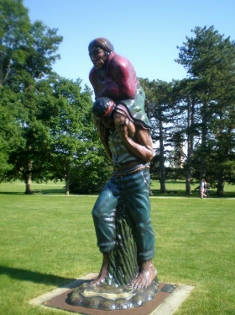

Figure 1: Border Crossing Sculpture

those who have suffered from discrimination in most of his works. Reflecting on his own Mexican heritage, Jimenez gives an “honor to laborers who face exploitation or even death by crossing the Rio Grande into the United States”. This sculpture of his is believed to depict his own grandfather, who at that time, with his grandmother and father, illegally crossed the border between Mexico and Texas in 1924 (The Museum of Fine Arts, Border Crossing, 2018).

This sculpture was purchased by the College of Consumer and Family Sciences of Iowa State University, it is placed facing LeBaron Hall to portray an idea that the immigrants are, in a sense, headed to the College of Family and Consumer Sciences for guidance or in hopes to improve their daily and family life (ISU, Border Crossing Sculpture). As a “symbol of family, immigration and the Hispanic culture, the location of the sculpture has made it more effective to serve its purpose”. I think its existence resonates well with the function of the Home Economics building which aims to deliver educations in areas such as human development and family studies. To Luis Jimenez, he wanted to make a piece that was dealing with the issue of illegal aliens. He thought people talked about aliens as if they landed from outer space, or as if they were not really people. He wanted to put a face on them and humanize them. He also wanted to deal with the idea of a family which is why he went back to his experience in El Paso where a scenario as presented on the “sculpture is a common sight” (The Museum of Fine Arts, Border Crossing, 2018).

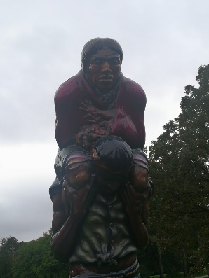

Figure 2: Infant in Arms

I do like this artwork a lot because the figures are depicted in motion to give a feeling of movement towards a goal and a will to survive, at the same time the figures appear fixed in time, exposed and in peril, that reminds me of the hardship people go through for a better life and it somehow reminds me to stay out of my comfort zone. I do think this is an important work, both

to all the domestic students to recognize something out of their daily lives and to recognize these people as they are and, also, to the alien students, as in the international students because it gives a sense of familiarity. Therefore, it really brings out an impact on ISU as it can show students how discrimination affects people’s life. After all, not all students from ISU have the same culture, history and hometown.

Works Cited

Milne, J. (2017, July 05). Border Crossing in a Trump Era. Retrieved April 1, 2019, from <https://www.museums.iastate.edu/about/blog/2017/07/05/border-crossing-in-a-trump-era>

Iowa State Collections. (n.d.). Retrieved April 1, 2019, from <http://umsm003.its.iastate.edu/view/objects/asitem/search@/0?t:state:flow=b3b5c2e9-5550-4169-8791-bf12a967d426>